Covid Crisis Website Resources
Resources | Links or Downloads | Type
250+ Creative Ways to Keep Your Family Sane During the COVID-19 Crisis | https://rochester.kidsoutandabout.com/content/250-creative-ways-keep-your-family-sane-during-covid-19-crisis | Family/General
FACE COVID Handout | Drive.google.com/uc?id=1_O8grFdwMDuGVIE_RvdRfhHhf6xf3ty8&export=download  Or click here for the Link | General
FACE COVID Video | www.youtube.com/watch?v=BmvNCdpHUYM | General
Coping with fear Meditation ~ 13 minutes | https://www.tarabrach.com/meditation-rain-fear/ | General
Guided Meditation for Time of Pandemic: | https://www.tarabrach.com/meditation-times-of-pandemic/ | General
Shine App - Care for your Coronavirus Anxiety Toolkit | https://www.virusanxiety.com | General
17 Totally Normal Things to Feel Right Now, According to Therapists | https://apple.news/AW5Az5U-ZQfi9DmYB_vWUhQ | General
Parentology | www.parentology.guide | Family
5 Ways to Help Children with COVID Anxiety | https://www.pesi.com/blog/details/1726/5-ways-to-help-children-with-coronavirus-anxiety?utm_medium=email&utm_source=sp&utm_campaign=040420_bh_s_ng_MIR_March_1pm_throttled&spMailingID=32104228&spUserID=OTkyODY3OTA2MzUS1&spJobID=1683153201&spReportId=MTY4MzE1MzIwMQS2 | Family
Online Tours  Museums, Zoos, and Theme Parks | https://www.goodhousekeeping.com/life/travel/a31784720/best-virtual-tours/ | Family/General
Treasure Hunt App for Kids | 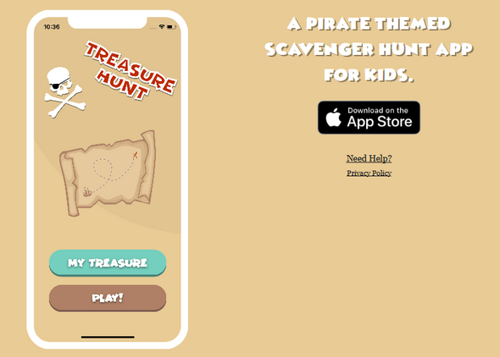 | Kids
Messenger Kids App | 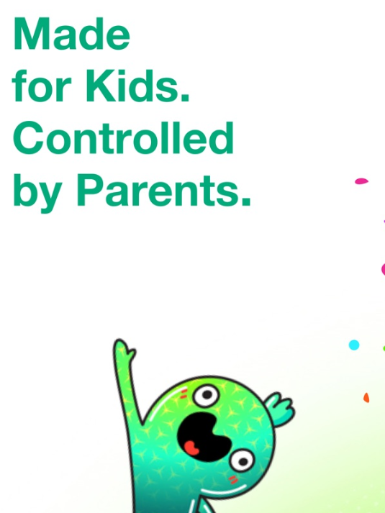 | Kids
Jib Jab App |  | Kids
Houseparty App |  | Family

